Lab Task-04
Output:
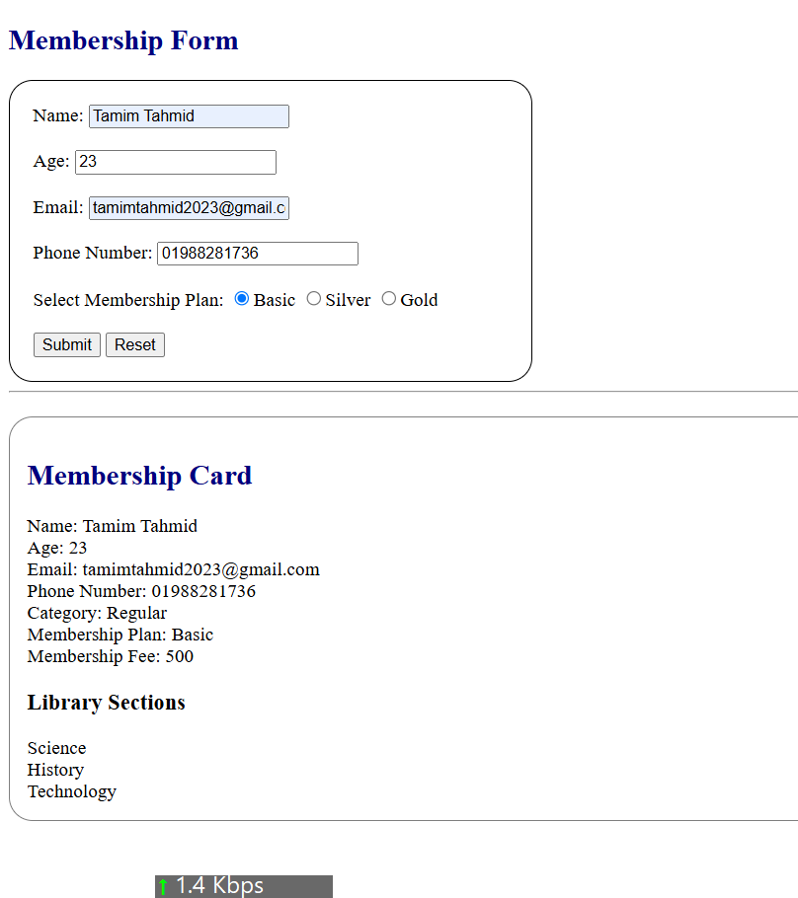

1.HTML:
<!DOCTYPE html>
<html>
<head>
<title>Library Membership Form</title>
<link rel="stylesheet"href="style.css">
</head>
<body>
<h2>Membership Form </h2>
<form id="membershipform">
<div>
<lebel for ="name">Name:</lebel>
<input type="text" name="name" id="name" required>
</div><br>
<div>
<lebel for ="age">Age:</lebel>
<input type="number" name="age" id="age" required>
</div><br>
<div>
<lebel for ="email">Email:</lebel>
<input type="email" name="email" id="email" required>
</div><br>
<div>
<lebel for ="phonenumber">Phone Number:</lebel>
<input type="number" name="phonenumber" id="phonenumber" required>
</div><br>
<div>
<lebel for ="membershipplan">Select Membership Plan:</lebel>
<input type="radio" name="membershipplan" id="p1">Basic
<input type="radio" name="membershipplan" id="p2">Silver
<input type="radio" name="membershipplan" id="p3" required>Gold
</div><br>
<div>
<input type="submit" name="Register">
<input type="reset" name="reset">
</div>
</form><hr>
<div id="output"></div>
<script src="script.js"></script>
</body>
</html>

2. CSS:
body{
font-display: Arial, sans-serif;
margin:20;
}
h2{
color: navy;
}
form{
width: 400px;
padding: 20px;
border: 1px solid black;
border-radius: 20px;
}
#output{
margin-top: 20px;
padding: 15px;
border: 1px solid gray;
border-radius: 20px;
}

3. js:

function showMemberCard(name, age, email, phonenumber, membershipplan) {
let sections = ["Science", "History", "Technology"];

console.log("Library Sections:");

let sectionOutput = "<h3>Library Sections</h3>";

for (let i = 0; i < sections.length; i++) {
console.log(sections[i]);
sectionOutput += sections[i] + "<br>";
}

document.getElementById("output").innerHTML =
"<h2>Membership Card</h2>" +
"Name: " + name + "<br>" +
"Age: " + age + "<br>" +
"Email: " + email + "<br>" +
"Phone Number: " + phonenumber + "<br>" +
"Category: " + (age < 13 ? "Junior" : "Regular") + "<br>" +
"Membership Plan: " + membershipplan + "<br>" +
"Membership Fee: " +
(membershipplan == "Basic" ? 500 :
membershipplan == "Silver" ? 1000 : 1500) +
"<br>" + sectionOutput;
}

document.addEventListener("submit", function(event) {
event.preventDefault();

let name = document.getElementById("name").value;
let age = document.getElementById("age").value;
let email = document.getElementById("email").value;
let phonenumber = document.getElementById("phonenumber").value;

let membershipplan = document.querySelector(
'input[name="membershipplan"]:checked'
);

membershipplan = membershipplan.id == "p1" ? "Basic" :
membershipplan.id == "p2" ? "Silver" : "Gold";

showMemberCard(name, age, email, phonenumber, membershipplan);
});

